J’apprends le français
Vocabulary Bank: Greetings  Bonjour – Good morning  Salut - Hi  Au revoir - Goodbye  Plus tard – See you later |  | Vocabulary Bank: Colours
 |  | bleu | noir | marron | jaune | rouge
 |  | gris | vert | blanc | violet | orange
Questions and Answers  Comment t’appelles-tu? – What’s your name?  Je m’appelle... – My name is...  Quel âge as-tu? – How old are you?  J’ai ____ ans. – I am ____ years old.  Ça va? – How are you?  Ça va bien. – I’m fine.  Ça va mal. – I’m not good at all.  Comme çi, comme ça. – Not bad. Okay.  Et toi? – And you? |  | Vocabulary bank: Numbers  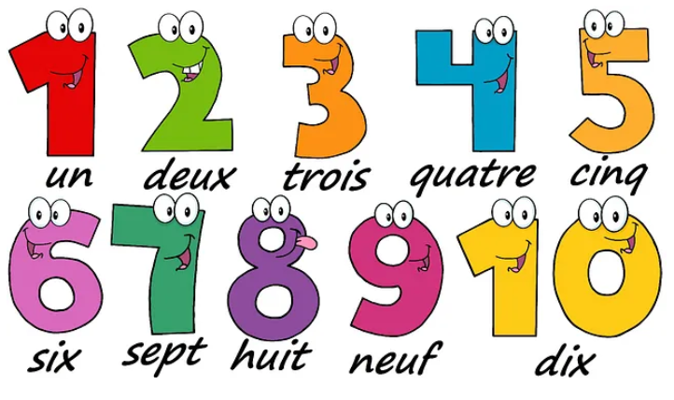
Phonics Bank – In this unit we will see:  - oi sound in ‘trois’ and ‘noir’  - on sound in ‘marron’  - ou sound in ‘rouge’ |  | Silent Letters  There are many last consonant silent letters in French. The final letter ‘s’ is silent in the words  ‘trois’ and ‘gris’. The final ‘t’ is silent in ‘vert’ and ‘violet’.
La phonétique
In this unit we will learn a selection of the key phonemes to help us with our French pronunciation.
mouton  (like ‘oo’ in ‘tooth’)  sheep | musique  (like ‘eek’ in ‘week’)  music | yeux  (like ‘euuhh’ in ‘bird’)  eyes
cochon  (like ‘onn’ in ‘honk’)  pig | famille  (like ‘eeyeh’ in ‘yes’)  family | quatre  (like ‘c’ in ‘cook’)  four
cheval  (like ‘sh’ in ‘shop’)  horse | café  (like ‘eh’ in ‘set’)  cafe | campagne  (like ‘nyuh’ in ‘onion’)  countryside
oiseau  (like ‘wah’ in ‘waffle’)  bird | règle  (like ‘ai’ in ‘air’)  ruler | français  (like ‘ss’ in ‘say’)  French
six  (like ‘ee’ in ‘see’)  six | appartement  (like ‘euh’ in ‘the’)  flat | dents  (like ‘on’ in ‘song’)  teeth
cinq  (like ‘an’ in ‘clang’)  five | bureau  (like ‘oh’ in ‘all’)  office | blanc  (like ‘on’ in ‘song’)  white

Les formes
Vocabulary Bank: Shapes  un triangle – a triangle  un carré – a square  un ovale – an oval  un cercle – a circle  un rectangle – a rectangle  un pentagone – a pentagon  un hexagone – a hexagon  un losange – a diamond  une ligne – a line  une étoile – a star |  | Phonics Bank – In this unit we will see:  - oi sound in ‘étoiles’  - guttural ‘r’ – the French ‘r’ sound is made from the back of the mouth, not the front, as heard in ‘cercle’  - silent letters – when ‘s’ or ‘x’ is the final consonant, it is nearly always a silent letter in French  - liaison – when a word ending in ‘x’ or ‘s’ is followed by a word starting with a vowel, the final consonant is pronounced (but with a sound like a ‘z’), e.g. deux ovales, les étoiles
Vocabulary Bank: Numbers |  | Grammar Bank  - plurals – the plural of many French nouns is formed by adding the letter ‘s’, e.g. étoiles  - nouns in French can be either ‘masculine’ or ‘feminine’, therefore there are 2 determiners for ‘a’ in French:  un is used for masculine nouns  une is used for feminine nouns  (les is used for plural nouns – both masculine and feminine)  Example: un carré (masculine)  une étoile (feminine)  les carrés  les étoiles
Questions and Answers
C’est de quelle forme? – What shape is it?
C’est un/une ... – It is a ...
Combien de côtés a un/une ________?
How many sides does a ________ have?
Un/Une ________ a ___ côtés
A ________ has ___ sides.

Les instruments

Vocabulary Bank: Musical instruments  la trompette – the trumpet  la guitare – guitar  la batterie – the drums  la flute à bec – the recorder  la clarinette – the clarinet  la harpe – the harp  le piano – the piano  le triangle – the triangle  le violon – the violin  les cymbals – the cymbals |  | Phonics Bank – In this unit we will see:  - ou sound in ‘joue’  - on sound in ‘violon’  - guttural ‘r’ – the French ‘r’ sound is made from the back of the mouth, not the front, as heard in ‘triangle’, ‘guitare’ and ‘clarinette’  - silent letters – the final letter ‘s’ is silent in both ‘les’ and ‘des’, pronounced like ‘leh’ and ‘deh’  - contraction - when the preposition ‘de’ is followed by the definite article ‘les’, it becomes ‘des’  - the four French nasal sounds (made through the nose and not the mouth) - on, un, in and an
Sentence Building  Use of the high frequency verb ‘jouer’ (to play) in first person singular:  Je joue de la (for feminine nouns)  Je joue du (for masculine nouns)  Je joue des (for plural nouns) |  | Grammar Bank  - Nouns in French have different determiners based on their gender. In this unit we will use the following three definite articles:  le for masculine singular nouns  la for feminine singular nouns  les for all plural nouns

